**SHELL SCRIPTING**

**>> Testing output for script**

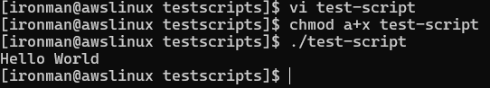

**>>Assigning tasks**

*#!/bin/bash*

*# Define small tasks*

*whoami*

*echo*

*pwd*

*echo*

*hostname*

*echo*

*ls -ltr*

*echo*

**>>Executing**

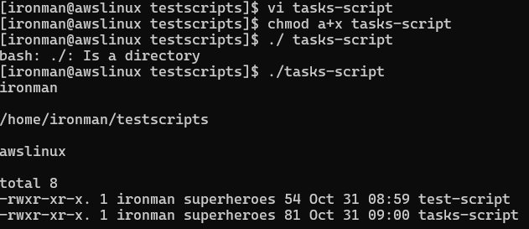

**>>Adding Variables:**

*#!/bin/bash*

*# Example of defining variables*

*a=Farsaan*

*b=Siddiqui*

*c=script-practice*

*echo "My first name is $a"*

*echo "My surname is $b"*

*echo "This is $c"*

**>>Executing**

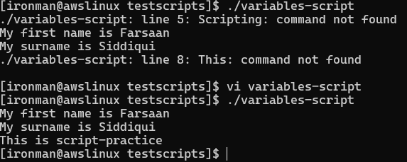

**>>Creating Read Script**

*#!/bin/bash*

*# Read user input*

*echo "What is your first name?"*

*read a*

*echo*

*echo "What is your last name?"*

*read b*

*echo*

*echo Hello $a $b*

**>>Executing**

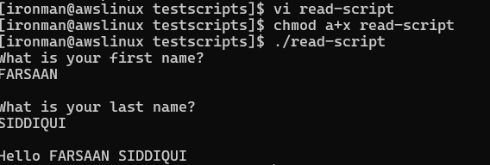

**>>commands script**

*# Script to run commands within*

*clear*

*echo "Hello `whoami`"*

*echo*

*echo "Today is `date`"*

*echo*

*echo "Number of user login: `who | wc -l `"*

**>>Executing**

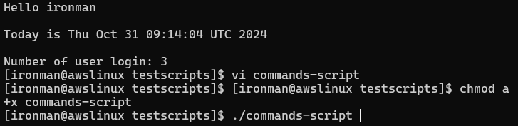

**>>Tasks script**

*#!/bin/bash*

*# Define small tasks*

*whoami*

*echo*

*pwd*

*echo*

*hostname*

*echo*

*ls -ltr*

*echo*

**>>Executing**

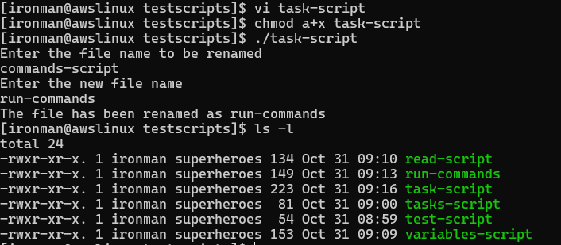

**>>Case script**

*#!/bin/bash*

*echo*

*echo Please chose one of the options below*

*echo*

*echo 'a = Display Date and Time'*

*echo 'b = List file and directories'*

*echo 'c = List users logged in'*

*echo 'd = Check System uptime'*

*echo*

*read choices*

*case $choices in*

*a) date;;*

*b) ls;;*

*c) who;;*

*d) uptime;;*

*\*) echo Invalid choice - Bye.*

*echo*

*esac*

**>>Executing**

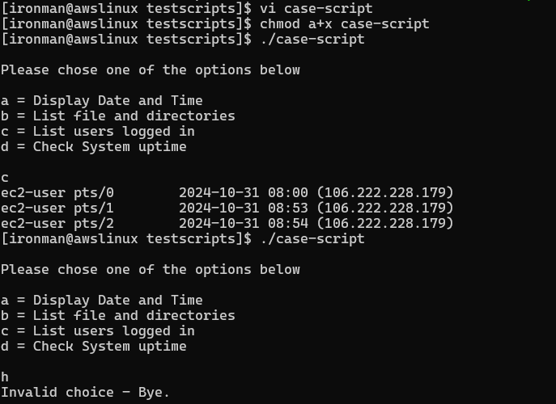

**>>loop script**

*#!/bin/bash*

*for i in {1..5}*

*do*

*touch $i*

*done*

**>>Executing**

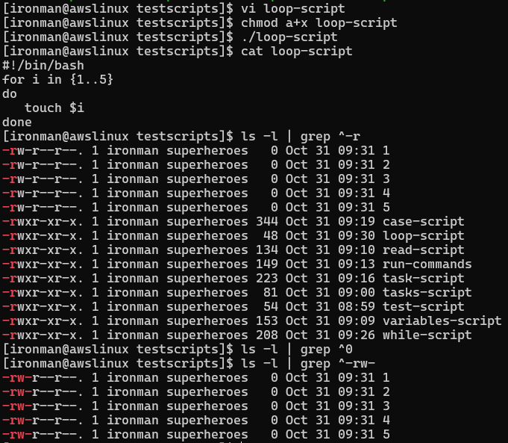

**>>Userloop**

*#!/bin/bash*

*i=1*

*for username in `awk -F: '{print $1}' /etc/passwd`*

*do*

*echo "Username $((i++)) : $username"*

*done*

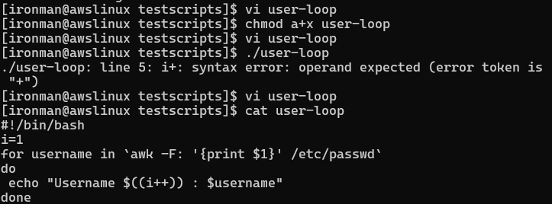

**>>Executing**

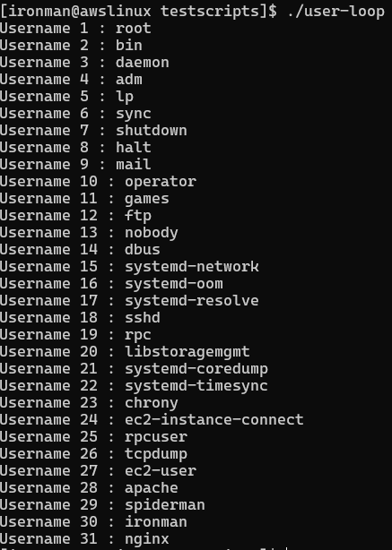

**>>if then script**

*#!/bin/bash*

*clear*

*echo*

*echo "What is your name?"*

*echo*

*read a*

*echo*

*echo Hello $a*

*echo*

*echo "Have you had lunch? (y/n)"*

*read Have*

*echo*

*if [ "$Have" == y ]*

*then*

*echo You are cool*

*elif [ "$Have" == n ]*

*then*

*echo You should try tea, it’s a good sweet*

*echo*

*fi*

**>>Executing**

